Seatwork # 1
Seatwork: My First Function
Course Code: CPE 007 | Program: Computer Engineering
Course Title: Programming Logic and Design | Date Performed: 10 – 16 - 25
Section: CPE11S1 | Date Submitted: 10 – 16 - 25
Name(s): Paula Esguerra | Instructor: Engr. Jimlord Quejado
6. Output
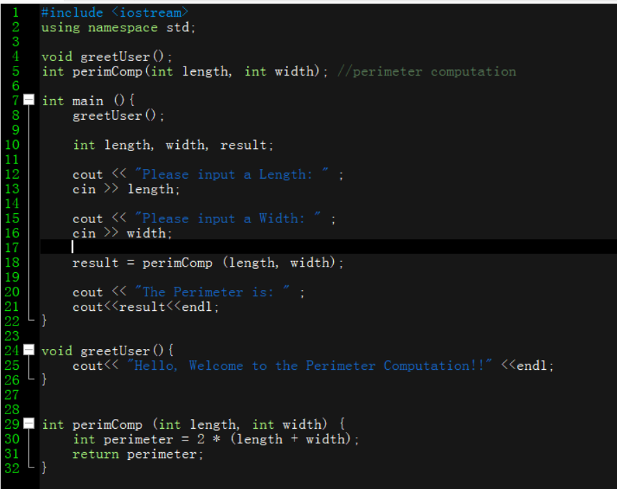
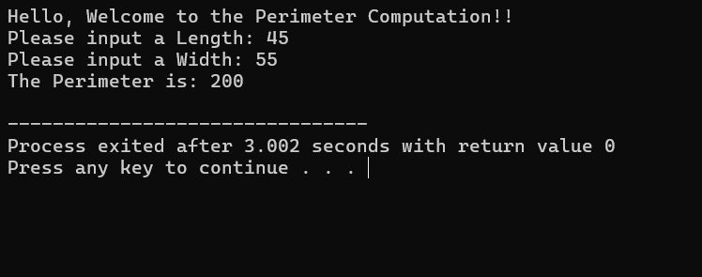

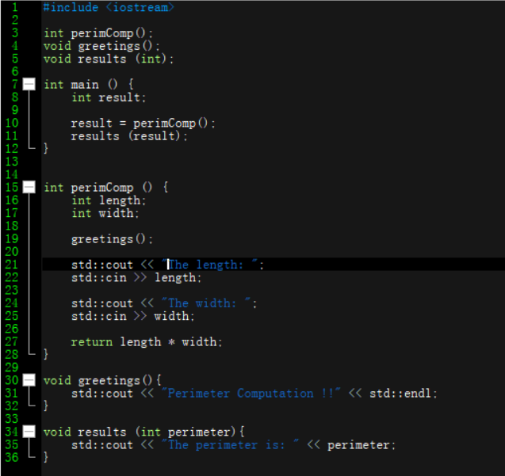
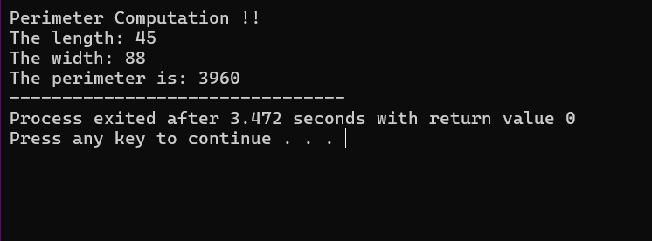

Using void is a bit confusing, but using void means returning the variable you need to return, or maybe don’t return at all. And then , a bit of examples I can maybe grasp using void and functions together.
7. Supplementary Activity
8. Conclusion
9. Assessment Rubric

